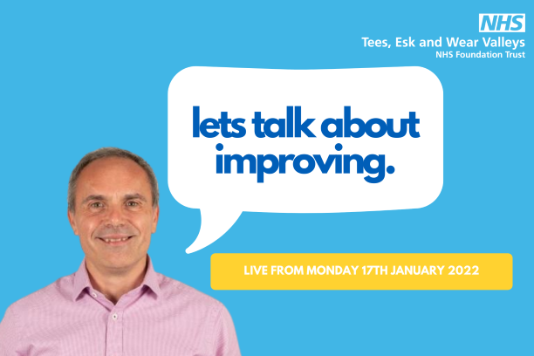
Hi, I’m Ahmad Khouja and I am leading the development of the Trust’s clinical journey. The clinical journey describes what it is we are aiming for when we redesign our services, and how we get there. By having it clearly stated, it helps us to avoid doing things which would undermine or delay us while we try to make that vision a reality.
However, I need your help. I have looked at all the previous feedback, comments, and suggestions we have had about how our services need to change. This is great, but I still have some key questions that I would really value your views and ideas on. This will help shape a draft clinical journey which we will put out for wider consultation.
To help us plan our way forward you can share your views in the following ways:
Click on this link or copy and paste it into your browser-https://tewvbigconversation.org
Write your answers on this document and send it to this Freepost address-
Let’s talk
FREEPOST TEWV

Write your answers on this document, scan it and send it to-tewv.bigconversation@nhs.net

- It is important we get right the principles of how we provide care. Some of the important ones that have come through to date are in these areas:
- always working together and in partnership, including shared decision-making
- being aware of people’s trauma (past and current), and not adding to it
- being more focussed on meeting person’s individual goals
- involving the people important in the person’s life much more
- always being able to offer choice over evidence-based interventions
Do you agree? What else should we include?

- Will we always need hospitals, or are there other ways we can support people in the community or their own homes?
- What would that alternative look like?
- How could we use technology to achieve this?

- How could we play a part in supporting those aspects of people’s lives which we know impacts on health and well-being (such as where they live, jobs, education, benefits)?
- Do you think we should play a bigger role in the prevention of problems developing? How could we do this?

- What are the current strengths that we should build on?
- When we get things right, we can make a real difference. What else do we need to do?

