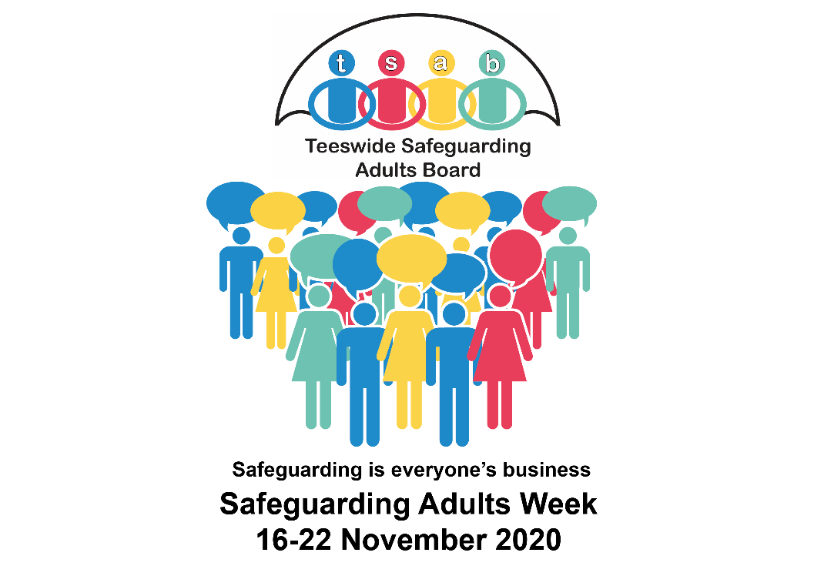

National Safeguarding Adults Week 2020
TSAB would like to encourage all partners to become involved in National Safeguarding Adults Week from 16-22 November 2020.
Across the week we aim to create a time where we can all focus on safeguarding adults and each day will focus on a particular theme. The Ann Craft Trust are co-ordinating national activity and further information can be found at www.anncrafttrust.org
Monday – Safeguarding and Wellbeing
Tuesday – Adult Grooming
Wednesday – Understanding Legislation
Thursday – Creating Safer Places
Friday – Organisational Abuse
Saturday – Sport & Activity
Sunday – Safeguarding in Your Community

Promoting the day
In light of the global health emergency and in times of lockdown and restrictions on public gatherings we have included below some ideas to promote the day and share key messages.

Share and promote TSAB Twitter and Facebook posts.
Follow us @TeeswideSAB
- Share and/or create posts on sites like Facebook, Twitter, and Instagram that help promote NSAW
- Share our Youtube channel and playlists
- Use the hashtag #SafeguardingAdultsWeek2020 in your posts. The more people sharing this hashtag, the more powerful the movement can be
- Promote key messages on your own social media accounts and specific social media groups
- Share key messages or post an article on your organisations internal intranet/newsletter/blog/vlog
- Revisit safeguarding messages – See It, Report It! Safeguarding is Everyone’s Business
- Share TSAB posters and literature with key contact details for reporting abuse https://www.tsab.org.uk/professionals/posters/
- Connect with your networks to raise awareness of this important topic
- Link in with bespoke support services
- Identify key stakeholders
Safeguarding Adults Week 2020 – Key Themes
The below information relates to each specific days theme, the text can also be used in social media posts to spread a consistent message across Tees.

Monday – Safeguarding and Wellbeing
There’s a strong link between safeguarding and mental and physical wellbeing, if someone’s wellbeing is suffering, they may consider certain actions that put them at risk. It's important to look after yourself, but it's just as important to look out for others. Learn to spot the signs that someone might not be doing so well and don't be afraid to ask: "Are you OK?

Tuesday – Adult Grooming
Grooming is a form of abuse that involves manipulating someone until they’re isolated, dependent, and more vulnerable to exploitation. When most people think about grooming, they think about children, however adults are vulnerable to grooming too. Grooming can lead to many different types of harm, including modern slavery, physical, sexual and financial abuse.
Signs of Grooming in adults – what to watch out for
TSAB Romance Scams Guidance
TSAB Scams & Staying Safe Online Guidance
Financial Abuse
Modern Slavery & Human Trafficking
Sexual Abuse & Exploitation
Other Forms of Exploitation

Wednesday – Understanding Safeguarding Legislation
All safeguarding matters are governed by certain legislation, including The Care Act and The Mental Capacity Act. This legislation might seem confusing at first however it is designed to be as easy as possible to understand and apply.
https://www.tsab.org.uk/key-information/legislation-guidance/
TSAB Legal Literacy Webinars – (Fully Booked)
• Wednesday 18th November 10am-12noon
• Wednesday 18th November 2pm-4pm
• Thursday 19th November 10am-12noon
• Thursday 19th November 2pm-4pm
• Friday 20th November 10am-12noon

Thursday – Creating Safer Places
Safeguarding is everyone’s responsibility.
Safeguarding refers to measures designed to protect the health, wellbeing and human rights of individuals, these measures allow children, young people and adults at risk to live free from abuse. Every organisation, small group and individual should be aware of their responsibility, in work and society.
What is your role in safeguarding? How can you make a difference to the lives of others?
- Learn about the different types of harm and abuse
- Discover how to spot the signs
- Record any concerns you have
- Report your concerns to your Local Authorities Safeguarding Adults Team

Friday – Organisational Abuse
Organisational abuse includes neglect and poor care practice within a specific care setting. This could be a hospital or a care home, but also the care you receive in your own home. Organisational abuse doesn’t have to involve physical violence, it can be something as small as insisting that a person in care must drink their tea at the same time every day. The abuse can either be a one-off incident or an ongoing culture of ill-treatment.
https://www.tsab.org.uk/key-information/general-public/organisational-abuse-2/

Saturday – Safeguarding Adults in Sport and Activity

Sunday – Safeguarding in Your Community

See below for Communication and Engagement Plan

Logos/Digital Images
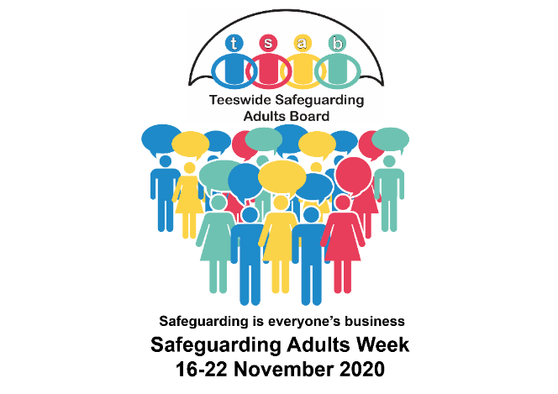

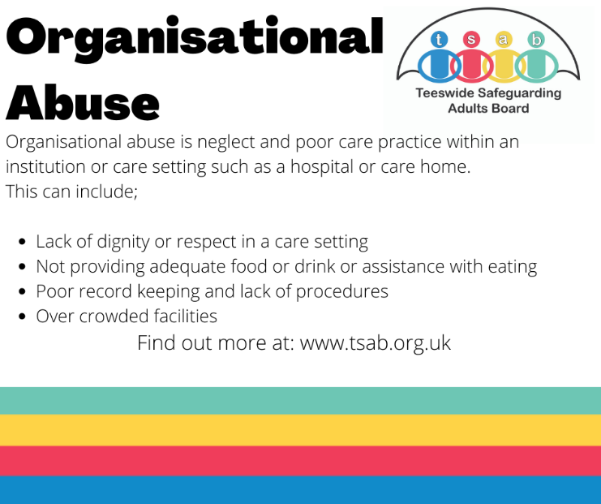

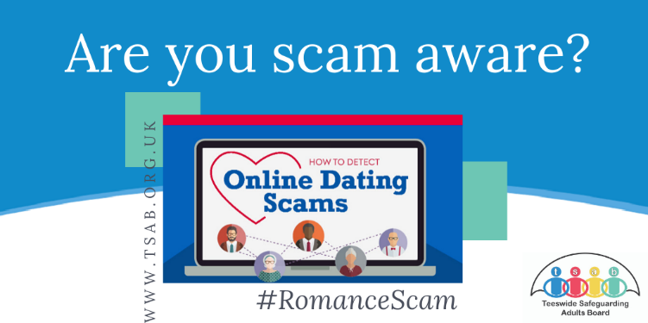
Timing of communication & Local/National campaigns/ awareness  (Stages of project, specific times, frequency) | Key activity, opportunities and events (Involvement activity, what is planned?) | Audience  (Who is expected to attend the event/engage with activity?) | Communication methods  (eg newsletter, website, printed materials, press release, poster, case study, social media, video, other) | Key messages to be communicated  (What do they need to know? Which questions should be answered?) | Stakeholders (Which organisation is hosting the event/ campaign/activity)
Monday 16 November 2020  Key Theme; Safeguarding & Wellbeing | 2 week Bus Stop Campaign to commence on 16th October to 29th October  Social Media activity  Zetland FM Radio Interview | All  Professionals and public  Zetland FM listeners | Bus Stop Advertisements across 10 Tees locations.  x3 Stockton, x3 Hartlepool, x2 Middlesbrough,  x2 Redcar  Facebook  Twitter  Radio/Social Media | See It Report It!  Adult Social Care contact number provided for each Local Authority  Raising awareness of the links between safeguarding and wellbeing.  Sources of support available.  Introduction to Safeguarding Week.  How to report concerns. | TSAB  Clear Channel  All  TSAB (Darren Best, Independent Chair)  Zetland FM
Tuesday 17 November 2020  Key Theme; Adult Grooming | Promotion of TSAB Guidance docs above (Romance Scams, Staying Safe Online etc)  RCBC Virtual Workshop  Provider Review Meeting/ Care Home Forum | Professionals and Public  Professionals – Multi-Agency  Organisations supporting adults with care needs | Social Media  Middleton Grange Shopping Centre  Thirteen Offices  Virtual Workshop |  | All  HBC  Thirteen  RCBC  Cleveland Police  RCBC Safeguarding Team
Wednesday 18 November  Key Theme; Understanding Legislation | Virtual Teams Webinar – Legal Literacy (Fully Booked)  2 hour morning session 10am-12pm  2 hour afternoon session 2pm-4pm | Professionals – Multi-Agency | Microsoft Teams Webinar | Understanding Legislation in Adult Social Care. | TSAB
 | RCBC Virtual Workshop | Social Care Practitioners | Virtual Workshop – Legislation |  | RCBC
Thursday 19 November  Key Theme; Creating Safer Places | Awareness of the  Safe Place Scheme across Tees  Virtual Teams Webinar – Legal Literacy (Fully Booked)  2 hour morning session 10m-12pm  2 hour afternoon session 2pm-4pm | Professionals – Multi – Agency | Microsoft Teams Webinar |  | TSAB  Safe Place Scheme Leads; SBC, HBC, MBC, RCBC (Skills for People)  TSAB
Friday 20 November  Key Theme; Organisational Abuse | Social Media Activity  Virtual Teams Webinar – Legal Literacy (Fully Booked) | Professionals and public  Professionals – Multi-Agency | Facebook & Twitter  Microsoft Teams webinar | What is Organisational Abuse?  (Image above for social media use)  Promotion of what a good organisation should look like  https://www.tsab.org.uk/key-information/general-public/organisational-abuse-2/ | All  TSAB
Saturday 21st November  Key Theme; Safeguarding in Sport and Activity  Sunday 22nd November  Key Theme; Safeguarding in Your Community  Other | Middlesbrough Football Club – Middlesbrough v Norwich  Liaison with libraries, leisure centres and sports facilities  Stockton News Residents Magazine Article  Domestic Abuse Virtual Workshop 18th November  Sticker Campaign #SafeguardingAdultsWeek  Targeting areas people use frequently to place stickers e.g. notice boards in all settings, transport and leisure facilities.  Promotion of TSAB Annual Consultation Survey 2020-21  Professionals Survey  General Public Survey  Easy Read Survey | All  Stockton-On-Tees residents  Social Care Professionals  All  Professionals  General Public  Service Users | Advert to feature on pitch banners  Magazine article  Virtual Workshop  Printed stickers in and around the community. To adhere to COVID secure arrangements.  Survey – Online and paper copies available | Safeguarding  How to report abuse  ‘Help protect others from abuse’  How to report concerns  Types of abuse incl: Domestic Abuse, Self-Neglect, Scams & Financial Abuse  Understanding the current challenges of supporting people who are experiencing Domestic Abuse and exploring the impact of Covid-19 upon abuse at home.  Raising general awareness of safeguarding  Have your say an inform the future priorities for safeguarding across Tees | TSAB  MFC  RCBC  SBC  RCBC  Foundation  RCBC to lead  TSAB  All

