Have your say

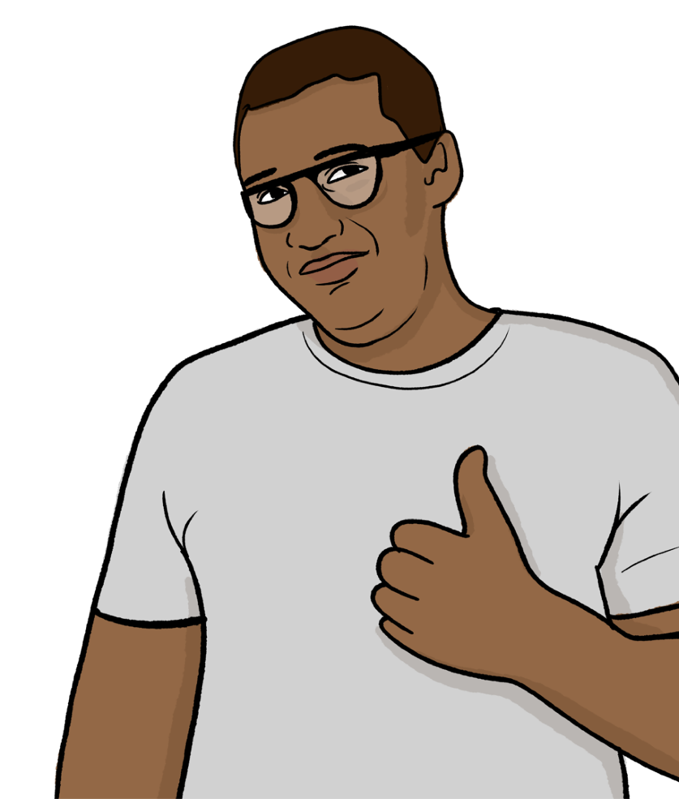

Easy Read

How to use this survey on a computer
You can complete this survey on your computer. First you will need to download it.

When you open the survey on your computer, you will be able to click on the tick boxes and write in the text boxes.

When you have finished the survey, save it to your computer and email a copy to:
healthwatchstockton@pcp.uk.net

Contents
Introduction 3
How we use your information 4
Questions 5
About you 13
Can we contact you? 24
For more information 26
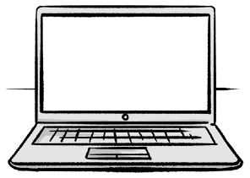
Bold words

links
In this Easy Read document, difficult words are in bold. We explain what these words mean in the sentence after they have been used.
Some words are pink and underlined.

These are links which will go to another website which has more information.

Introduction
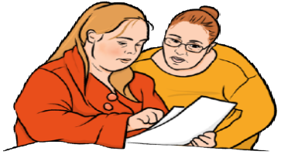

We are Healthwatch. We work to make sure health and care services are the best they can be for the people who use them.

We want to know if you think there are things that health and care services can do to improve.
Please answer these questions to tell us.
If you need advice or information about local services, talk to your local Healthwatch.
You can find your local Healthwatch website: https://www.healthwatchstocktonontees.co.uk/

How we use your information

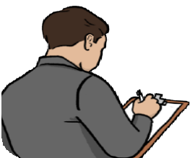
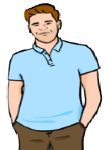
We will use the information you give us to spot things that could be better.

We might use the things you say in reports, but we will not use your name.

If you are giving us information for someone else, make sure you have asked them first.

You can find out more about how we use your information on this website: https://www.healthwatchstocktonontees.co.uk/privacy

Questions
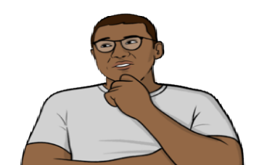
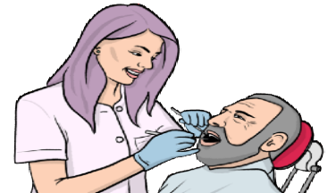
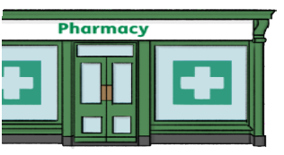
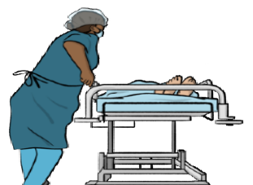

Question 1: What kind of service would you like to tell us about?
You can pick more than 1.

GP services - this is your local doctor

Dentists

Pharmacies

Hospital inpatient - this
means staying in hospital overnight

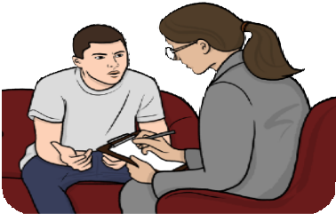
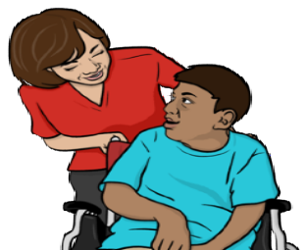
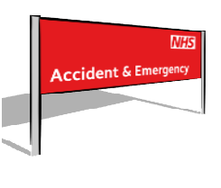
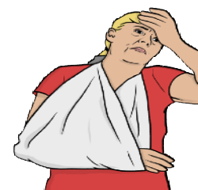
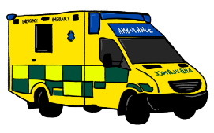

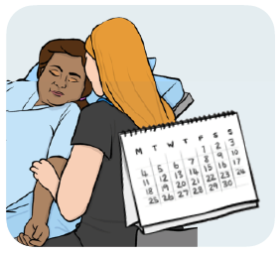

Hospital appointments - this means you have planned to go to hospital for some care

Mental health support

Social care - this is support for people who need some help with everyday things, in care homes or at home

Accident and emergency, or minor injury units - this is where you go if you are injured

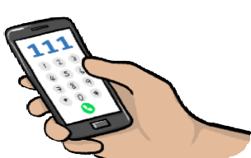
Ambulances and paramedics - this is who takes you to hospital if you need to go right away

NHS 111 - this is a phone line you can call for health advice

Other issue or service - please tell us which service you are talking about

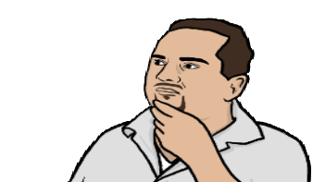
Question 2: Please tell us about what happened to you.

Think about:
          - What went well?
          - What could have been better?

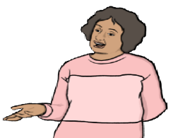
Question 3: Are you talking about a particular service, like a part of a hospital or your local doctor?
I’m talking about…

If so, please tell us which one.

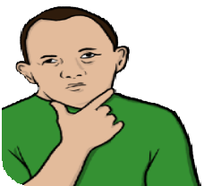

Question 4: How easy was it to get the help and support you needed?

Very easy

Easy

Neither easy nor difficult

Difficult

Very difficult

None of these

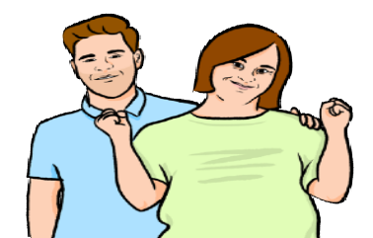

Question 5: How good would you say your care was?

Good

Neither good nor bad

Bad

Sometimes good, sometimes bad

Not sure

None of these

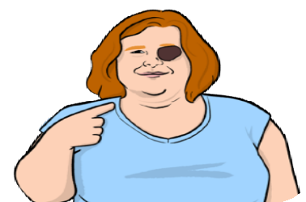
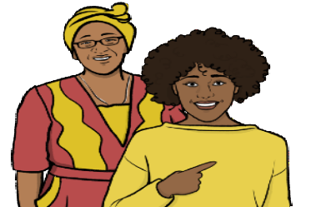
Question 6: Are you…

The person who got the care

A friend, family member or carer of the person who got the care

Someone else

About you

It would be helpful to know more about you.

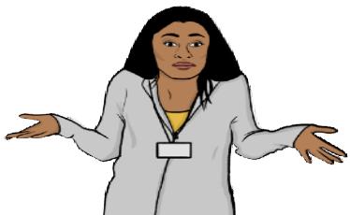

This helps us see if different people get better or worse care.

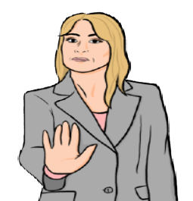

You do not have to answer these questions.

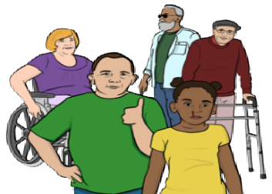

Question 7: How old are you?

16 to 17 years old

18 to 24 years old

25 to 49 years old

50 to 64 years old

65 to 79 years old

80 years old or older

Prefer not to say

Question 8: What is your gender?
Gender is whether you like to be known as male, female or something else.

Woman

Man

Non-binary - this means you are not a woman or man.

Prefer not to say

I prefer to use my own word

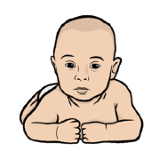

Question 9: Is your gender the same as the one you were given when you were born?

Yes

No

Prefer not to say

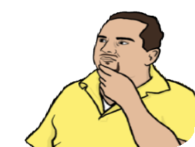

Question 10: What is your sexual orientation?
Sexual orientation means which gender you are attracted to. For example male, female or both.

Asexual - this means you are not attracted to anybody

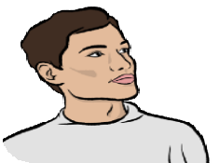
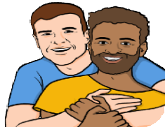
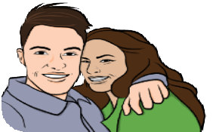
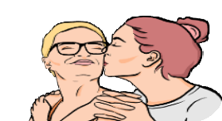
Bisexual - this means you are attracted to men and women

Gay man - this means you are a man who is attracted to other men

Heterosexual or Straight - this means you are attracted to the opposite gender
Lesbian or Gay woman - this means you are a woman who is attracted to other women
Pansexual - this means you are attracted to people no matter their gender

Prefer not to say
I prefer to use my own word

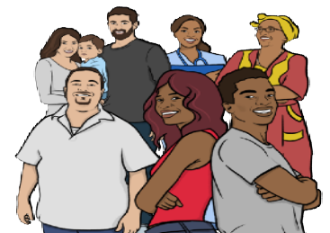
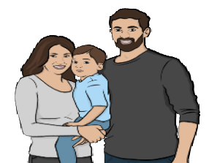
Question 11: What is your ethnicity?
Ethnicity is your race or background. For example Black, White or Asian.

Arab

Asian or Asian British
Bangladeshi

Chinese

Indian

Pakistani

Any other Asian or Asian British background

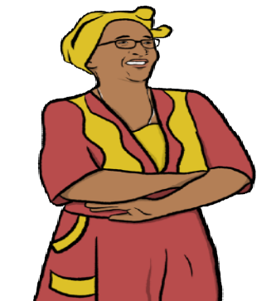
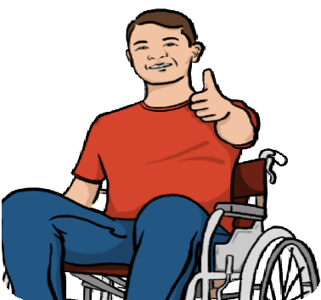
Black or Black British
African

Caribbean

Any other Black or Black British background

Mixed or more than 1 ethnicity
Asian and White

Black African and White

Black Caribbean and White

Any other Mixed or more than 1 ethnicity

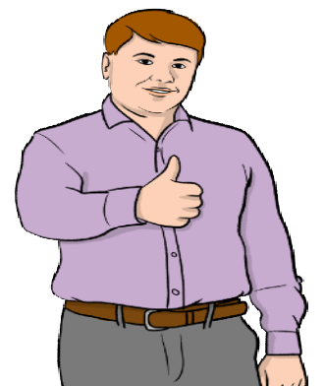
White
British, English, Northern Irish, Scottish or Welsh

Irish

Gypsy, Traveller or Irish Traveller

Roma
Any other White background

Prefer not to say

Any other ethnicity

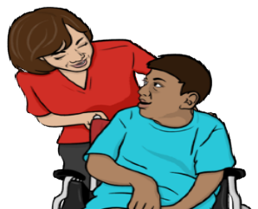

Question 12: Are any of these true for you?

I have a disability

I have had a health condition for a long time

I am a carer

None of these

Prefer not to say

Question 13: How much money do you have?

I have plenty to spend on things I need, and plenty left for extras I want

I have enough to spend on things I need, and a small amount for extras I want

I have enough to spend on things I need, and not much else

I don't have enough for things I need and sometimes run out of money

I don't know

Prefer not to say

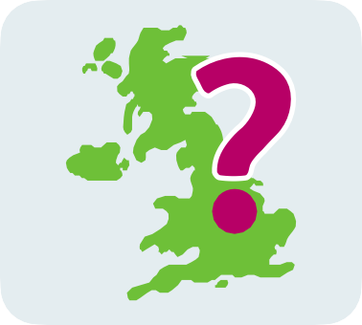

Question 14: What area do you live in?

Can we contact you?

Using your story
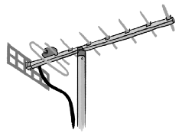
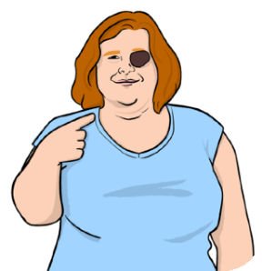
We use the stories people tell us when we talk about our work to the media.
@
The media is newspapers, radio or TV.
Can we contact you if we want to talk about your story to the media?
We will not give them your name without asking you first.

Yes

No

If you ticked yes, please write your name and email address in this box:

Emails
@
Would you like us to email you with information about what we are doing?

You can stop getting emails from us at any time.

Yes

No

If you ticked yes, please write your name and email address in this box:

For more information
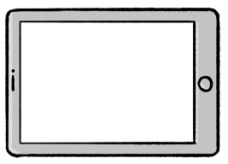
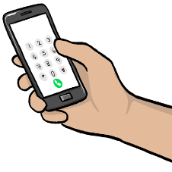
@

You can look at our website here: www.healthwatchanytown.co.uk

If you need more information please contact us by:

- phone: 00000 000 000

- email: email@healthwatchanytown.co.uk

